**Chapter 2- Color Theory**

# Color Models

***Color*** is an attribute of objects (like *texture, shape, smoothness,* etc.). Any method for explaining the properties or behavior of color within some particular context is called ***a color model***. No single model can explain all aspects of color, so we make use of different models to help describe different color characteristics. There are different methods involving red, green, and blue (*RGB*) components, which we use for generating displays on video monitors. Several other color descriptions are useful as well in computer-graphics applications. Some methods are used to describe color output on printers and plotters, some are used for transmitting and storing color information, and others are used to provide a more intuitive color-parameter interface to a program.

Color spaces are the mathematical representation of a set of colors. There are many color models. Some of them are *RGB*, *CMYK*, *YIQ*, *HSV*, and *HLS*, etc. These color spaces are directly related to saturation and brightness. All of these color spaces can be derived using RGB information using devices such as cameras and scanners.

* ***Color Importance***
* Color is an excellent *descriptor*: Suitable for object Identification and Extraction.
* Discrimination: Humans can distinguish thousands of color shades and intensities but few shades of gray levels***.***
* ***There are two contexts for image color processing***
* Full-Color Image Processing
  + Color is acquired with a full-color sensor
* Pseudo-Color Image Processing
  + Assigning colors to monochrome images
* There are many theories, measurement techniques, and standards for colors - no single theory of human color perception is universally accepted.
* Color of an object depends not only on the object itself, but also on:
* The light sources illuminating it
* The color of surrounding area
* The human visual system (the eye/brain mechanism)
* Some objects reflect light (wall, desk, paper), while others transmit light (cellophane, glass)
* **The Electromagnetic Spectrum**

In physical terms, color is electromagnetic radiation within a narrow frequency band. Some of the other frequency groups in the electromagnetic spectrum are referred to as radio waves, microwaves, infrared waves, and X-rays. Figure 1 shows the approximate frequency ranges for these various aspects of electromagnetic radiation.

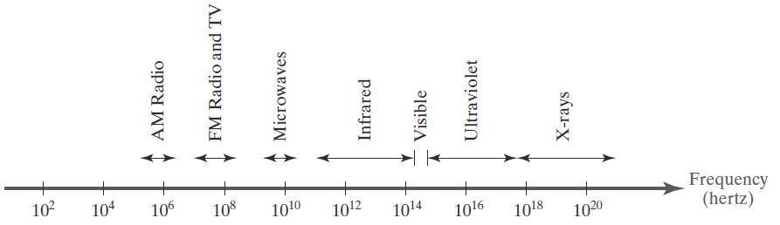

Figure 1 Electromagnetic spectrum frequency ranges

Each frequency value within the visible region of the electromagnetic spectrum corresponds to a distinct spectral color. At the low-frequency end (approximately 3.8×1014 hertz) are the red colors, and at the high-frequency end (approximately 7.9 × 1014 hertz) are the violet colors. Actually, the human eye is sensitive to some frequencies into the infrared and ultraviolet bands. Spectral colors range from shades of red through orange and yellow, at the low-frequency end, to shades of green, blue, and violet at the high end. In the wave model of electromagnetic radiation, light can be described as oscillating transverse electric and magnetic fields propagating through space. The electric and magnetic fields are oscillating in directions that are perpendicular to each other and to the direction of propagation. For each spectral color, the rate of oscillation of the field magnitude is given by the frequency f.

* Newton Experiments (Spectral Analyzer)
* Emerging light is no longer white but a continuous spectrum of color from violet to red (Fig.2).
* Six broad region: violet, blue, green, yellow, orange, and red.

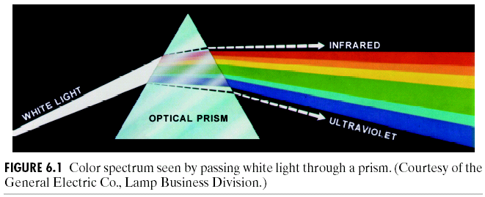

Figure 2 Prism color analysis

* ***Chromatic Light***
* Span the electromagnetic spectrum from 400 to 700 nm

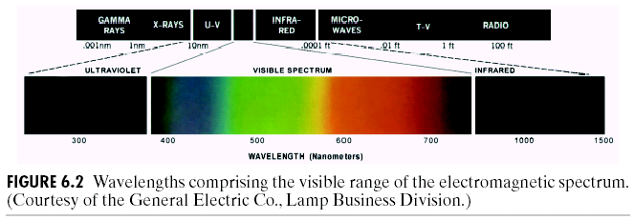

Figure 3 Wavelengths comprising the visible range of the electromagnetic spectrum

* Radiance:
  + Total amount of energy that flows from light source (W)
* Luminance:
  + The amount of energy that an observer *perceives* from light source. (IR case: R may be high while L is zero)

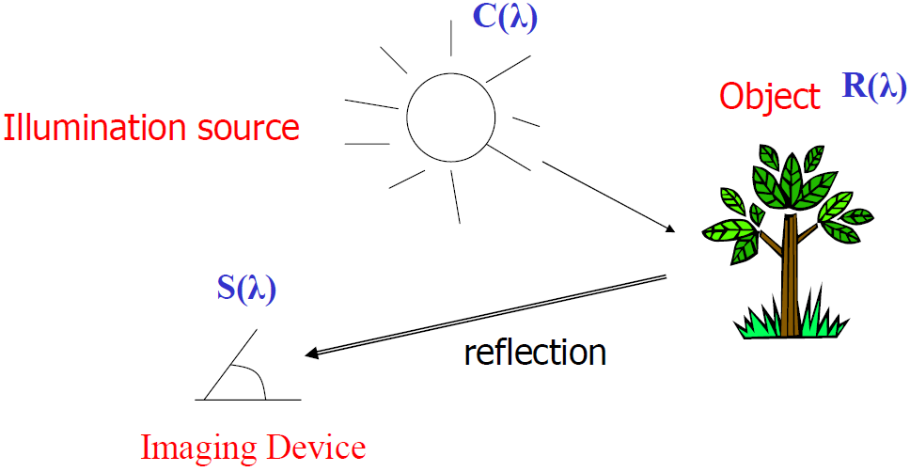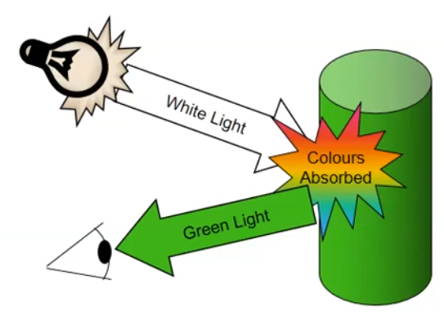

Figure 4 luminance of objects

* Brightness:
  + Subjective description, practically impossible to measure (Subject dependent).
* ***Hue, Saturation, and Brightness***
  + Hue: Dominant color (wavelength) perceived by an observer. (Red, Orange, Yellow, and etc.)
  + Saturation: relative purity of color or the amount of *white* light mixed with a hue.
    - Pure colors are fully saturated.
    - Pink is less saturated.
  + Brightness: chromatic notion of intensity.
  + ***Chromaticity***: Hue + Saturation
* ***Properties of Light***

Light exhibits many different characteristics, and we describe the properties of light in different ways in different contexts. Physically, we can characterize light as radiant energy, but we also need other concepts to describe our perception of light.

* Light is fundamental of color vision
* Achromatic light (BW Television): its only attribute is its Intensity (gray level refer to a scalar measure of its intensity that range from black to white).
* Chromatic light (Color TV): Radiance, luminance, and Brightness
* Light is an Electromagnetic wave
* The wave which wavelength (pure) is between ~400nm and ~700nm is detectable by human eye and called a monochromatic (not gray level!) light.
* λ < 400nm: Ultraviolet
* λ > 700nm: Infrared
* **Human visual system**

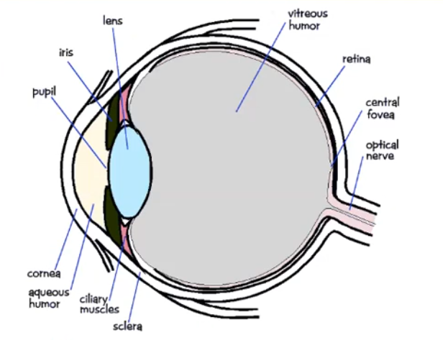

Figure 5: human visual system

Light hit the retina which contain photosensitive cells that convert the spectrum into a few discrete values. There are two types of photosensitive cells (Fig.5):

* **Cones**: sensitive to colored light but not very sensitive to dim light.
* **Rods**: sensitive to achromatic light

We perceive color through three types of cones for red, green, and blue.

* **Standard Primaries and the Chromaticity Diagram**

Because no finite set of light sources can be combined to display all possible colors, three standard primaries were defined in 1931 by the International Commission on Illumination, referred to as the CIE (Commission Internationale de l’ ´ Eclairage). The three standard primaries are imaginary colors. They are defined mathematically with positive color-matching functions that specify the amount of each primary needed to describe any spectral color. This provides an international standard definition for all colors, and the CIE primaries eliminate negative-value color-matching and other problems associated with selecting a set of real primaries.

* **The XYZ Color Model**

The set of CIE primaries is generally referred to as the XYZ color model, where parameters X, Y, and Z represent the amount of each CIE primary needed to produce a selected color. Thus, a color is described with the XYZ model in the same way that we described a color using the RGB model.

* **Normalized XYZ Values**

In discussing color properties, it is convenient to normalize the amounts in Equation against the sum X + Y + Z, which represents the total light energy. Normalized amounts are thus calculated as

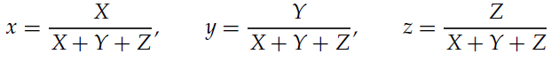

Because x+y+z = 1, any color can be represented with just the x and y amounts. Also, we have normalized against total energy, so parameters x and y depend only on hue and purity and are called the chromaticity values. However, the x and y values alone do not allow us to describe all properties of the color completely, and we cannot obtain the amounts X, Y, and Z. Therefore, a complete description of a color is typically given with three values: x, y, and the luminance Y. The remaining CIE amounts are then calculated as

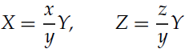

where z = 1 − x − y. Using chromaticity coordinates (x, y), we can represent all colors on a two-dimensional diagram.

* **The CIE Chromaticity Diagram**

When we plot the normalized amounts x and y for colors in the visible spectrum, we obtain the tongue-shaped curve shown in Figure 6.

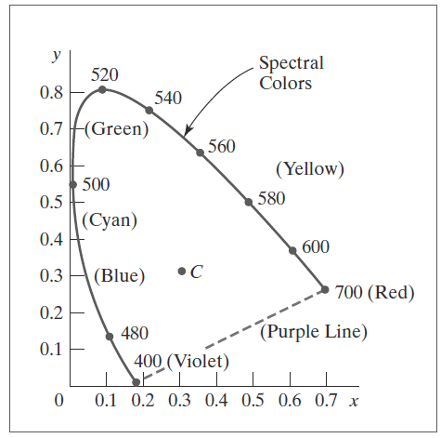

Figure 6 CIE chromaticity diagram for the spectral colors

This curve is called the CIE chromaticity diagram. Points along the curve are the spectral colors (pure colors). The line joining the red and violet spectral points, referred to as the purple line, is not part of the spectrum. Interior points represent all possible visible color combinations. Point C in the diagram corresponds to the white-light position. Actually, this point is plotted for a white light source known as illuminant C, which is used as a standard approximation for average daylight. Luminance values are not available in the chromaticity diagram because of normalization. Colors with different luminance but with the same chromaticity map to the same point. The chromaticity diagram is useful for:

• Comparing color gamuts for different sets of primaries.

• Identifying complementary colors.

• Determining purity and dominant wavelength for a given color

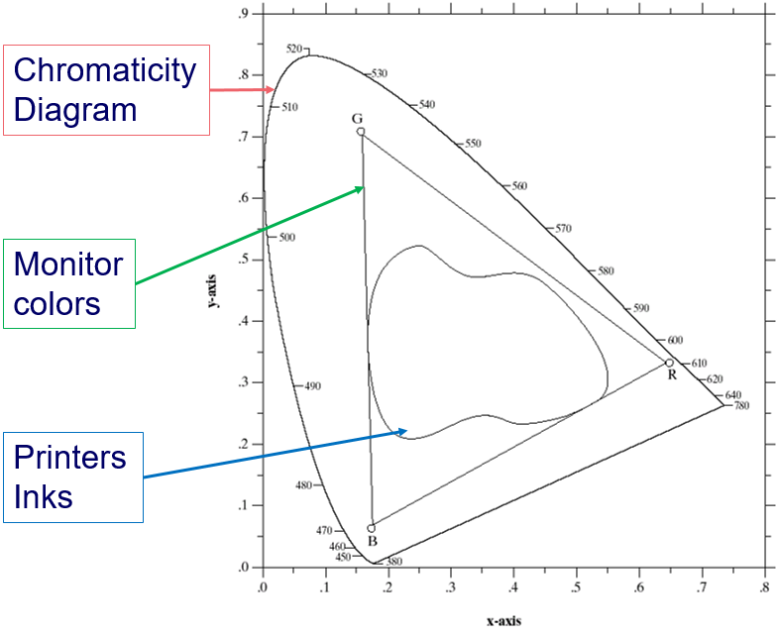

Figure 7 Chromaticity diagram

* Available color systems are dependent on the medium with which a designer is working. When printing/painting, an artist has a variety of paints to choose from, and mixed colors are achieved through the ***subtractive*** color method. When a designer is utilizing the computer screen to generate digital media, colors are achieved with the ***additive*** color method.
* **Subtractive Color.**
* When we mix colors using paint, or through the printing process, we are using the subtractive color method. Subtractive color mixing means that one begins with white and ends with black; as one adds color, the result gets darker and tends to black (as seen in Fig. 8)).

Figure 8: subtractive color models

* The CMYK (Cyan-Magenta-Yellow-Black) color system is the color system used for printing.
* **Additive Color.**
* If we are working on a computer, the colors we see on the screen are created with light using the additive color method. Additive color mixing begins with black and ends with white; as more color is added, the result is lighter and tends to white (Fig. 9).

Figure 9: Additive color models

* The RGB (Red-Green-Blue) colors are light primaries and colors are created with light.
* **Light and Color**

Table 1: A comparison between color and light

|  |  |
| --- | --- |
| **Color** | **Light** |
| Color is a **perceptual phenomenon** | Light is a **physical phenomenon** |
| Response of the human **visual system** to light and other factors | Electromagnetic radiation visible to the ***human eye***  Emitted in quanta called **photons**  Has **wavelength** and **amplitude** |

* **Achromatic Light**
* Achromatic Light - "without color", quantity of light only
* Called intensity, luminance, or measure of light’s energy/brightness
* Refer to Gray levels - We can distinguish approximately 128 gray levels
* Seen on black and white displays (Fig. 10)
* Eye is much more sensitive to slight changes in luminance (intensity) of light than slight changes in color (hue)



Figure 10: Achromatic light

* **Chromatic Light**
* 3-space of largely independent perceptual parameters
  + **Brightness / intensity** - this circular color picker shows single brightness
  + **Chromaticity / color:**
    - **Hue / position in spectrum (red, green, …)** - angle in polar coordinates (circular color picker)
    - **Saturation / vividness** - radius in polar coordinates (circular color picker) (Fig. 11)

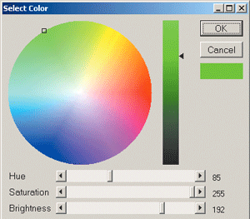

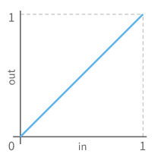Figure 11:chromaticity and color

Figure 12: constant luminosity

* **Gamma Correction**
* Human visual response better at distinguishing darker shades (Fig 12,13).
* Greyscale bars that increase by a constant amount of luminosity:
* Greyscale bars with luminosity increasing according to a power law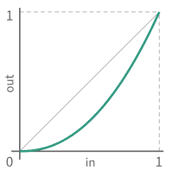

Figure 13: luminosity increasing by power law



* **Color Mixture**
* There are two color mixtures:
  + **Subtractive mixture** -The effect of passing light through several filters
  + **Additive mixture** - The effect of throwing different lights upon the same spot.
* **Subtractive Mixture**
* Subtractive mixture occurs when mixing paints, dyes, inks, etc. that act as a filter between the viewer and the light source / reflective surface.
* The light passed by two filters (or reflected by two mixed pigments) are wavelengths that are passed by the two filters
* **Additive Mixture**
* Additive mixture occurs when color is created by mixing visible light emitted from light sources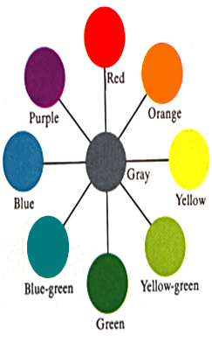

Figure 14:complementary hues

* Used for computer monitors, televisions, etc.
* Light passed by two filters (or reflected by two pigments) impinges upon same region of retina
* **Complementary Hues – Additive Mixture**
* Any hue will approach gray if additively mixed with its opposite hue on the color circle (Such hue pairs are complementary).
* These “unique” hues play a role in opponent color perception.
* Note that combining two complementary hues can never equal gray.
* **Color Contrast**
* Difference in perceived brightness.
  + **Example:**
    - Patch on the blue background looks brighter than the one on yellow. Result of brightness contrast

Figure 15: color contrast

* 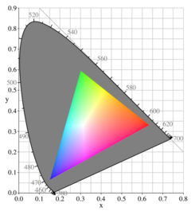**Color Gamut**

Figure 16: color gamut

* The color gamut for the model is the set of all colors that we can produce from the primary colors (Fig. 16).
* Two primaries that produce white are referred to as complementary colors. Examples of complementary color pairs are red and cyan, green and magenta, and blue and yellow.
* The subset of colors which can be accurately represented within a given color space or by a certain output device and ink combination.
* The complete set of colors found within an image at a given time.
* Converting a digitized image to a different color space alters its gamut.
* No finite set of real primary colors can be combined to produce all possible visible colors. Nevertheless, three primaries are sufficient for most purposes, and colors not in the color gamut for a specified set of primaries can still be described using extended methods.
* **Color model** (color space or system: is a specification of colors in a standard way, a coordinate system that each color is represented by a single point.).

Color model to study:

* Hardware oriented models:
  + - RGB model for color monitors and video camera
    - CMY model for color printing
* Image processing oriented (developing algorithms depends on color description that are natural intuitive to human)
  + - HIS (decouple the color and the gray scale information in an image)

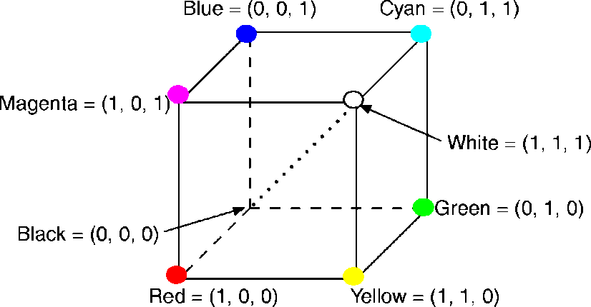

Figure 17: The RGB color model

* **The RGB Color Model**
* RGB are additive color models. In which colors are produced by adding components.
* Main diagonal represents gray levels
  + **From RGB cube:**
    - black is (0, 0, 0)
    - white is (1, 1, 1)
* Differs from one display to another.
* The color model RGB is used in hardware applications like PC monitors, cameras and scanners.
* **Pixel Depth:** The number of bits used to represent each pixel in RGB space.
* **Full-color** image: 24-bit RGB color image.

EX. (R, G, B) = (8 bits, 8 bits, 8 bits)

Number of colors: (28)3 = 16,777,216

* **Save RGB colors**
* **Subset of colors** is enough for some application
* **Safe RGB colors** (safe Web colors, safe browser colors)
* Only 6 levels of each primary colors are used.
* 63 = 216
* Differs by company too:
  + **Adobe RGB:** 
    - larger space
    - Currently the standard for digital photography
  + **sRGB (HP/Microsoft):**
    - Fewer colors, but allocated **bit depth better and more than** enough for most on-screen and Web uses
    - **Most monitors** now cover 100% of sRGB space
* **The CMY(K) Color Model**
* Used in electrostatic and in ink-jet plotters that deposit pigment on paper.
* Cyan, magenta, and yellow (secondary colors of light, primary of pigments) are complements of red, green, and blue (primary colors of light)

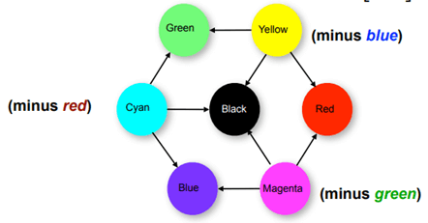

Figure 18: The CMY(K) color model

* Used for printed material.
  + Where white can be obtained by the absence of colors while black is obtained by combining all three colors.
* Subtractive primaries - Colors are determined by what is subtracted from white light, rather than by what is added to blackness
  + - white is at **origin**, black at (1, 1, 1):

* **RGB and CMY Transformation:**

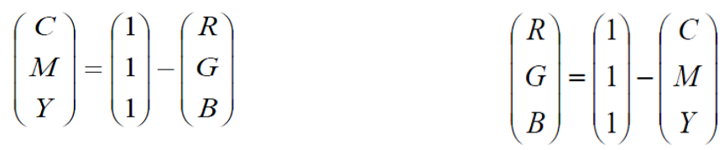

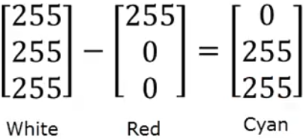 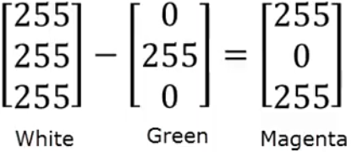 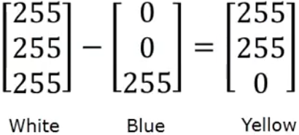

Figure 19: The RGB and the CMYK transformation

* **RGB and CMYK**
* The RGB color space uses light in colors of red, green, and blue to create the visible spectrum.
* Our eyes see color in terms of reflected light, so the observed world is closer to RGB than CMYK.
* Three colors of light, red, green and blue make white light.
* Three inks, cyan, magenta and yellow make black.
* In practice this black lacks intensity, so a separate black (K) is usually added.
* Red, green and blue are made from CMYK.

# RGB and HSV/HSI/HSL Color Space Conversion

HSV (hue-saturation-value), HSI (hue-saturation-intensity) and HSL (hue-saturation-lightness) are the three most common cylindrical-coordinate representations of points in an RGB color model. The HSV/HSI/HSL representations rearrange the geometry of RGB in an attempt to be more intuitive and perceptually relevant. The representations HSV, HSI and HSL are very similar, but not completely identical.

The hue component *H* in all three color spaces is an angular measurement, analogous to position around a color wheel. A hue value of 0°corresponds to red, 120° corresponds to green, and 240° corresponds to blue. The saturation component in all three color spaces describes color intensity. A saturation value of 0 (in the middle of a hexagon) means that there is no color (gray). A saturation value at the maximum (at the outer edge of a hexagon) means that the colorfulness value is at maximum for the color defined by the hue. HSV model is called a single hexagon model. The top of the hexagon corresponds to maximum intensity V=1. The maximum saturation is available for maximum intensity. The bottom converges to one point that corresponds the color black. The HSI model is called a double hexagon model. The bottom is similar to HSV but the top also converges to one point that corresponds to the color white. The line between top point and bottom point corresponds to varying shades of gray. For the HSI model, the maximum saturation is available at a medium grey intensity. The HSL model is also a double hexagon model, where lightness is defined as the average of the largest and smallest color components.

* **The HSV Color Model**
* Refer to Hue, saturation, value (brightness)
* Hexcone subset of cylindrical (polar) coordinate system
* The cross-section at V = 1 contains the RGB model’s R = 1, G = 1, B = 1

Figure

* + 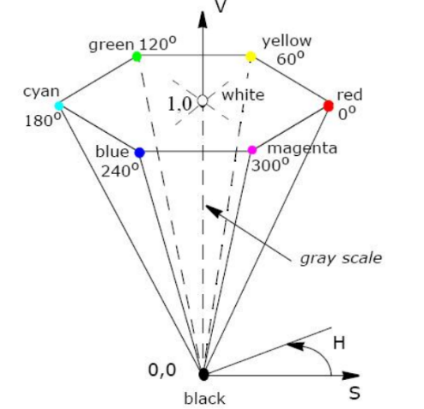**Example:**
    - Pure red : H = 0, S = 1, V = 1 (, 1, 1)
* Tints: adding white pigment means decreasing S at constant V
* Shades: adding black pigment means decreasing V at constant S
* **Generating tones with hue, value and saturation**

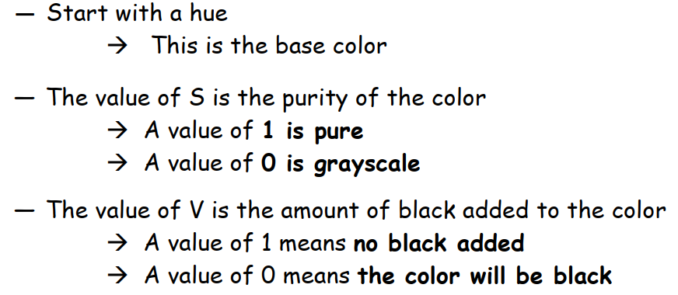

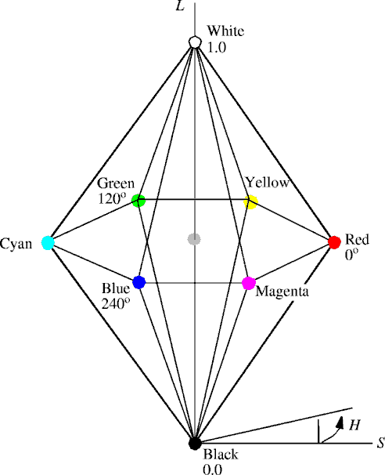

Figure

* **The HLS Color Model**
* Refer to Hue, lightness, saturation
* Double-hexcone subset of XYZ space
* Maximally saturated hues are at S = 1, L = 0.5
* Conceptually easier for some people to view white as a point
* **The HSI Color Model**
* Human description of color is not RGB or CMY**K**
* Human description of color is Hue, Saturation and Brightness:
  + Hue: color attribute
  + Saturation: purity of color
  + Brightness: achromatic notion of intensity
* RGB to HSI conversion

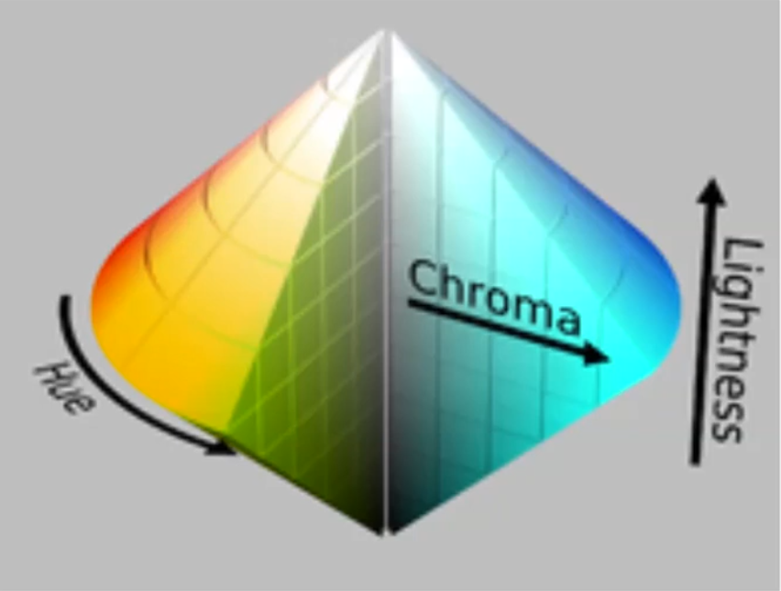

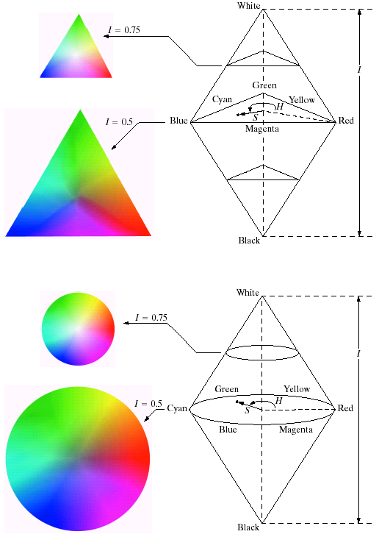

Figure 24 HSI color model

* **Convert RGB model to HIS**

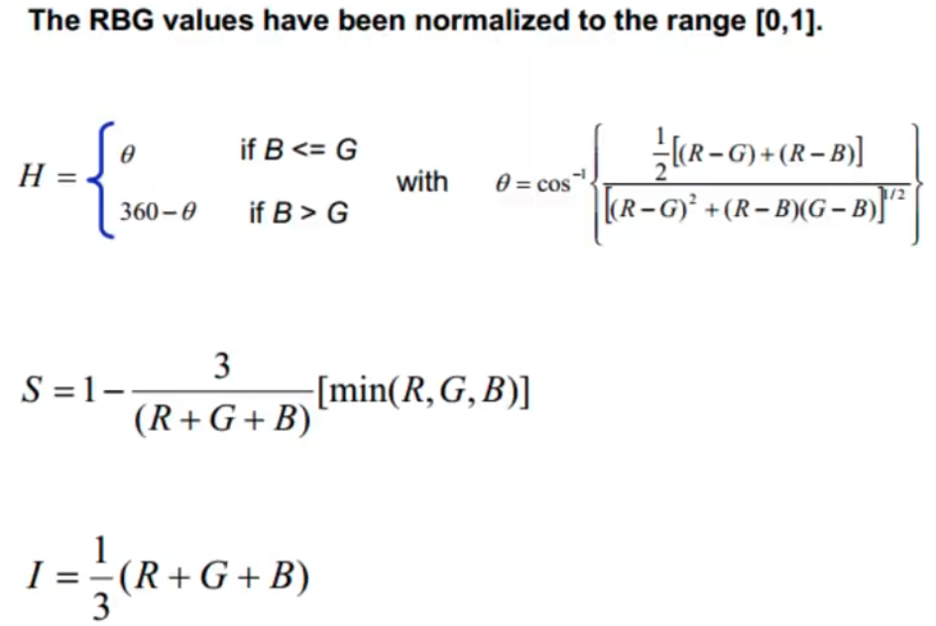

EX:

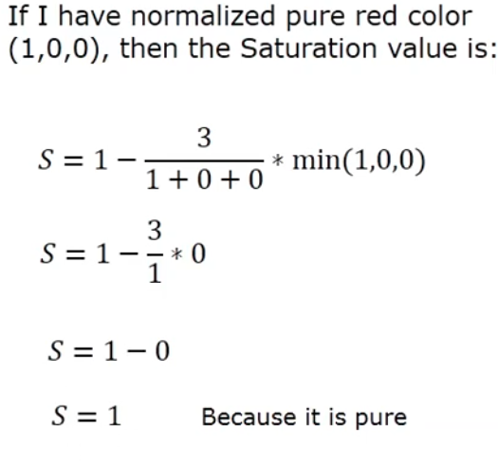 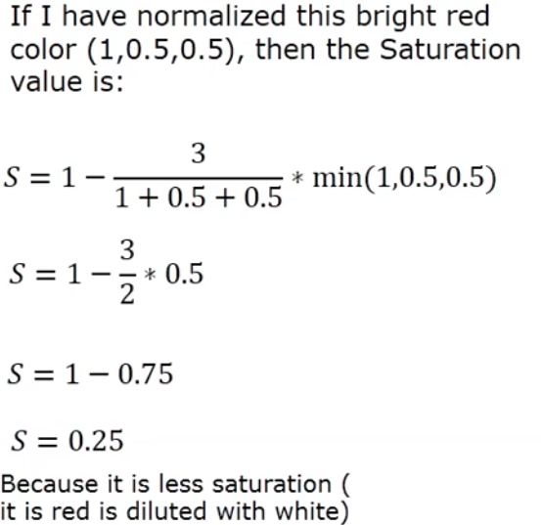

* **The YIQ Color Model**
* Recoded RGB for transmission efficiency, compatibility with B/W broadcast TV;
* used for NTSC (National Television Standards Committee (cynically, “Never The Same Color”))
* Y = CIE’s Y (luminance); I and Q encode chromaticity

Table 2:A comparison between different color models

|  |  |
| --- | --- |
| **Color Model Application Area** | **Color Model Application Area** |
| RGB | * Computer graphics * Image processing * Image Analysis * Image Storage |
| CMY(K) | Printing |
| HSV, HSL | * Human visual perception * Computer graphics processing * Computer Vision * Image Analysis * Design image * Human vision * Image editing software * Video editor |
| YIQ | TV broadcasting  Video system |

# An Introduction to Color Theory and Color Palettes[1]

User interface (UI) designers have the challenging task of incorporating color into their interface in a way that poignantly communicates a brand’s visual identity. While it might seem like a website’s color palette is a matter of the client’s personal taste, in reality, UI designers rely on a framework called color theory: a multilayered set of guidelines that informs the use of color in design.

***What is color theory?***

Let’s start at the basics: what actually is color theory?

Color theory is a framework that informs the use of color in art and design, guides the curation of color palettes, and facilitates the effective communication of a design message on both an aesthetic and a psychological level.

Modern color theory is largely based on Isaac Newton’s color wheel, which he created all the way back in 1666. The basic color wheel displays three categories of color; primary colors, secondary colors, and tertiary colors. If you remember learning about these in art class, well done—you’ve already grasped the basics of color theory!

***Let’s have a quick refresh on what these color categories entail:***

* **Primary colors**   
  are colors you can’t create by combining two or more other colors. The primary colors are red, blue, and yellow.
* The **secondary colors**   
  are orange, purple, and green—in other words, colors that can be created by combining any two of the three primary colors.
* **Tertiary colors**   
  are created by mixing a primary color with a secondary color. The tertiary colors are magenta, vermillion, violet, teal, amber, and chartreuse.

## 3 wheels depicting the primary, secondary and tertiary colors

Figure 25: color categories

## **More Details about Primary, secondary and Tertiary Colors[2]**

### **Primary Colors**

Primary colors are those you can't create by combining two or more other colors together. They're a lot like prime numbers, which can't be created by multiplying two other *numbers* together.

*There are three primary colors:*

* **Red**
* **Yellow**
* **Blue**

Think of primary colors as your parent colors, anchoring your design in a general color scheme. Any one or combination of these colors can give your brand guardrails when you move to explore other shades, tones, and tints (we'll talk about those in just a minute).

When designing or even painting with primary colors, don't feel restricted to just the three primary colors listed above. Orange isn't a primary color, for example, but brands can certainly use orange as their dominant color (as we at HubSpot know this quite well).

Knowing which primary colors *create* orange is your ticket to identifying colors that might go well with orange -- given the right shade, tone, or tint. This brings us to our next type of color ...

### **Secondary Colors**

Secondary colors are the colors that are formed by combining any two of the three primary colors listed above. Check out the color theory model above -- see how each secondary color is supported by two of the three primary colors?

There are three secondary colors: **orange**, **purple**, and **green**. You can create each one using two of the three primary colors. Here are the general rules of secondary color creation:

* Red + Yellow = **Orange**
* Blue + Red = **Purple**
* Yellow + Blue = **Green**

Keep in mind that the color mixtures above only work if you use the purest form of each primary color. This pure form is known as a color's *hue*, and you'll see how these hues compare to the variants underneath each color in the color wheel below.

### **Tertiary Colors**

Tertiary colors are created when you mix a primary color with secondary color.

From here, color gets a little more complicated. And if you want to learn how the experts choose color in their design, you've got to first understand all the other components of color.

The most important component of tertiary colors is that not every primary color can match with a secondary color to create a tertiary color. For example, red can't mix in harmony with green, and blue can't mix in harmony with orange -- both mixtures would result in a slightly brown color (unless of course that's what you're looking for).

Instead, tertiary colors are created when a primary color mixes with a secondary color that comes next to it on the color wheel below. There are six tertiary colors that fit this requirement:

* Red + Purple = **Red-Purple** (magenta)
* Red + Orange = **Red-Orange** (vermillion)
* Blue + Purple = **Blue-Purple** (violet)
* Blue + Green = **Blue-Green** (teal)
* Yellow + Orange = **Yellow-Orange** (amber)
* Yellow + Green = **Yellow-Green** (chartreuse)
* **Introduction to the color wheel**

You might be thinking, “there are way more than 12 colors out there.” You’re right—and they can all be found on a more advanced version of the color wheel.

* An artist creates a color painting by mixing color pigments with white and black pigments to form the various shades, tints, and tones in the scene.

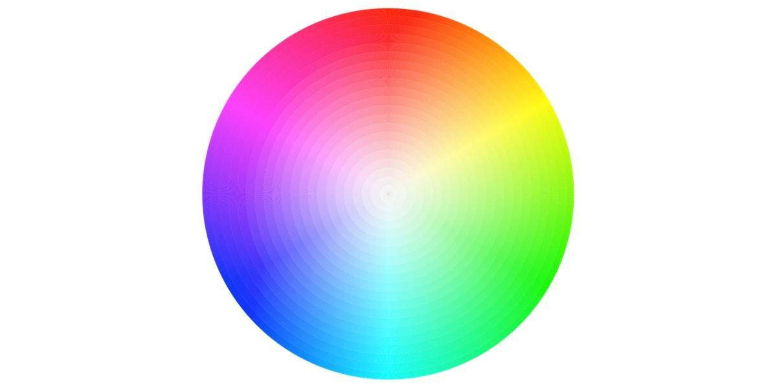

Figure 6: color wheel

The color wheel doesn’t just chart each primary, secondary, and tertiary color—it also charts their respective hues, tints, tones, and shades. By visualizing how each color relates to the color that comes next to it on a rainbow color scale, the color wheel helps designers to create bespoke color palettes that promote aesthetic harmony. Let’s dive into these color variants a little deeper:

### ***Hue***

Hue refers to the pure pigment of a color, without tint or shade. In that respect, hue can be interpreted as the origin of a color. Any one of the six primary and secondary colors is a hue.

### ***Shade***

Shade refers to how much **black** is added into the hue. As such, shade darkens a color.

### ***Tint***

The opposite of shade, tint refers to how much **white** is added to a color. As such, tint lightens a color.

#### **Tone (or Saturation)**

Tone is the result of a color that has had **both white and black** added to it. In other words, tone refers to any hue that has been modified with the addition of grey—as long as the grey is purely neutral (only containing white and black).

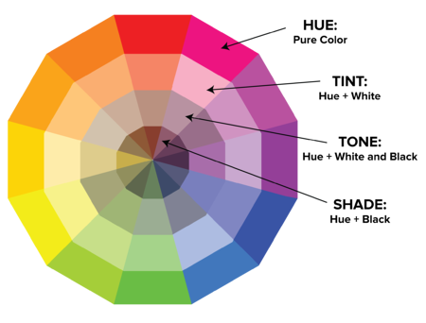

Figure 7:Color wheel (Tint, Tone and Shade)

* **Color temperature**

Even if you’re a design beginner, you’ve likely heard the terms “warm, cool and neutral” terms. This is referred to as color temperature, and it’s an essential consideration when it comes to color theory:

1. **Warm colors** contain **shades** of **yellow** and **red**;
2. **cool colors have a blue, green, or purple tint**;
3. **Neutral colors** include **brown, gray, black, and white**.

The temperature of a color has a significant impact on our emotional response to it. Within the psychology of colors, for example, warm colors show excitement, optimism, and creativity, whereas cool colors symbolize peace, calmness, and harmony.

* **The importance of color harmony**

Arguably the most crucial aspect of color theory, color harmony refers to the use of color combinations that are visually pleasing for the human eye. Color palettes can either promote contrast or consonance, but as long as they make sense together, they can still result in a visually satisfying effect.

When it comes to UI design, color harmony is what all designers strive to achieve. Based on the psychological need for balance, color harmony engages the viewer and establishes a sense of order. A lack of harmony in a color palette can either result in an interface being under-stimulating (boring) or over-stimulating (chaotic and messy).

* **Introduction to color palettes**

So far, we’ve explored the various forms that a color can take, and gotten acquainted with the color model that you’ll use as a UI designer. Now, let’s dive into the fun part: color palettes!

A color palette is a combination of colors used by UI designers when designing an interface. When used correctly, color palettes form the visual foundation of your brand, help to maintain consistency, and make your user interface aesthetically pleasing and enjoyable to use.

While color palettes date back thousands of years, color palettes are commonly used in digital design, presented as a combination of HEX codes. HEX codes communicate to a computer what color you want to display using hexadecimal values. Back in the ’90s, most digital color palettes only included eight colors. Now, designers have a myriad of shades and hues from the color wheel to choose from.

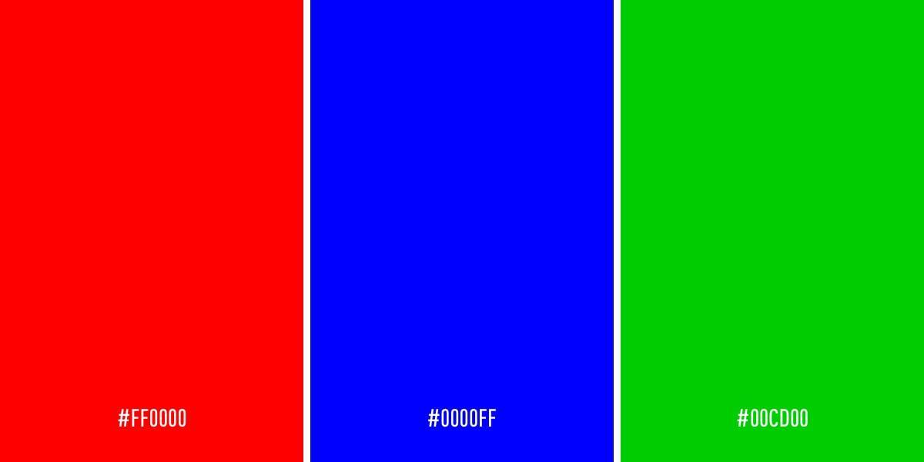

Figure 8: Color palettes

Over the next few sections, we’ll learn how to choose and interpret a color palette to ensure you’re creating the best possible interface for your users.

## ***What are the different types of color palettes?***

Colors can be combined to form one of five color palettes that are commonly used by UI designers. Let’s go through them together.

### **Monochromatic**

A popular choice with designers, monochromatic color schemes are formed using various tones and shades of one single color.

### **Analogous**

An analogous color scheme is formed of three colors that are located next to each other on the color wheel. Analogous color palettes are commonly used when no contrast is needed—for example, on the background of web pages or banners.

|  |
| --- |
| Note: Choose one color to dominate, a second to support. The third color is used (along with black, white or gray) as an accent.  analogous color scheme  Figure 9: Analog color scheme |

### **Complementary**

Complementary color palettes are colors that are placed in front of each other on the color wheel. While the name may suggest otherwise, complementary color palettes are actually the opposite of analogous and monochromatic color palettes, as they aim to produce contrast. For example, a red button on a blue background will stand out on any interface.

Note: Complementary colors are really bad for text[3].

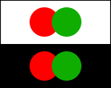

Figure 10: Complementary color scheme

### **Split-complementary**

The split-complementary color palette differs from the complementary color palette only in that it employs a higher number of colors. For example, if you choose the color blue, you’ll then need to take the two colors that are adjacent to its opposite color, which in this case would be yellow and red.

|  |
| --- |
| Note: The split-complementary color scheme is often a good choice for beginners, because it is easy and often produces a good match.  split-complementary color scheme  Figure 11:Split-complementry color palette |

### **Triadic**

The triadic color scheme is based on three separate colors that are equidistant on the color wheel. Most designers employ the triadic color scheme by choosing one dominant color, and using the other two colors as accents.

|  |
| --- |
| Note: To use a triadic harmony successfully, the colors should be carefully balanced - let one color dominate and use the two others for accent.  triadic color scheme  Figure 12: Triadic color scheme |
|  |

### **Tetradic (rectangle)[4]**

Commonly used by more experienced designers, the tetradic color scheme employs two sets of complementary pairs—four colors from the color wheel in total that should form a rectangle when connected. While it’s a little harder to balance, it makes for a visually stunning end effect

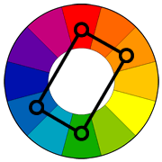

Figure 13: Tedradic color scheme

|  |
| --- |
| Note: You should also pay attention to the balance between warm and cool colors in your design.  rectangle color scheme  Figure 14 |

also, there are a variation of this scheme named (**square**)[5]. The square color scheme is similar to the rectangle, but with all four colors spaced evenly around the color circle. The square color scheme works best if you let one color be dominant.

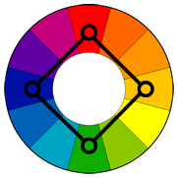

Figure 15

You should also pay attention to the balance between warm and cool colors in your design.

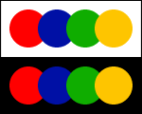

Figure 16

The next figure summarizes all those patterns[6]:

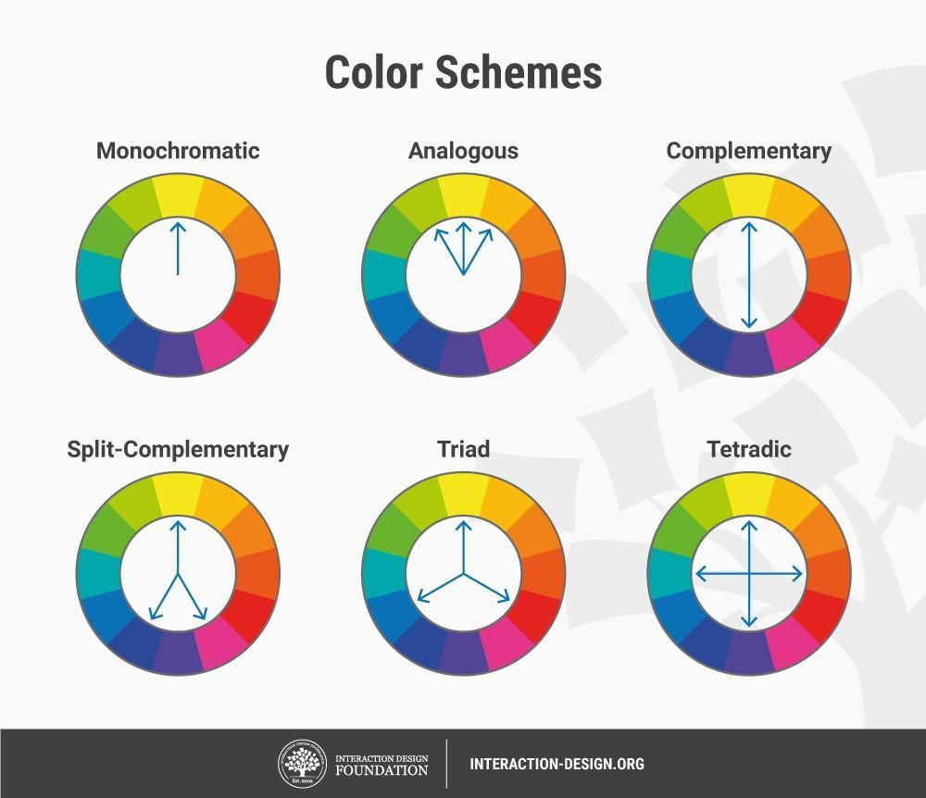

Figure 17: A summary for color palletes

## **How to choose a color palette?**

When choosing a color palette for your user interface, here are a few things to consider:

### **Research your audience**

Emotional responses to colors can depend on a range of personal factors, including gender, cultural experiences, and age. Before you get started with choosing your color palette, be sure to establish who your audience is. What are their common traits, and what are their expectations? What brands relating to yours are popular among your target audience—and how can you out-do their designs?

Conducting structured, thorough research on your target audience will not only help you to fine-tune the story you want to communicate, but it will also help you to prevent a potentially catastrophic design failure.

### **Consider color psychology**

With clarity on your target audience, it’s time to look at the psychology behind your potential brand colors. Color psychology is a branch of psychology surrounding the influence of colors on human mood and behavior. According to color psychology, the human mind subconsciously reacts and interprets colors in a way that influences our actions.

let’s take a look at some of the most common color associations below:

* **Orange** is **energetic** and warm. Some common associations with orange include creativity, enthusiasm, lightheartedness, and affordability.
* **Red** is the color of **blood**, so it’s often associated with **energy**, war, **danger**, and **power** but sometimes **good feelings**. Some common associations with red include action, adventure, aggression, and excitement.
* **Yellow** evokes positivity, youth, **joy**, playfulness, sunshine, and warmth.
* **Pink** evokes feelings of innocence and delicateness, gratitude, **softness**, and appreciation.
* **Blue** is perceived as authoritative, dependable, and **trustworthy**. Common associations with blue include calmness, serenity, confidence, dignity, and security.
* **Green** is the color of **nature**. It symbolizes growth, freshness, serenity, money, health, and healing.
* **Black** represents power, **elegance**, and authority. Common associations with black also include class, distinction, formality, mystery, secrecy, and seriousness.

### **Use some UI conventions**

When working with colors, it’s easy to get carried away with aesthetics over practicality. Of course, your interface should be visually pleasing—but it also needs to be accessible, easy to navigate, and enjoyable to use. Of course, it’s great to be experimental—but challenging design conventions with “edgy” designs can confuse your users, and make them work harder than they need to.

**Some common UI design color conventions include:**

* Using a dark color for text to ensure legibility
* Keeping light colors for backgrounds
* Using contrasting colors for accents (as mentioned above)
* Sticking to classic call-to-action colors—such as red for a warning sign

Sticking to these conventions will reduce the cognitive load for your users, and allow them to navigate the interface intuitively.

### **Consider your color context[7].**

Color context refers to how we perceive colors as they contrast with another color. Look at the pairs of circles in the example below to see what I mean.

The middle of each of the circles is the same size, shape, and color. The only thing that changes is the background color. Yet, the middle circles appear softer or brighter depending on the contrasting color behind it. You may even notice movement or depth changes just based on one color change.

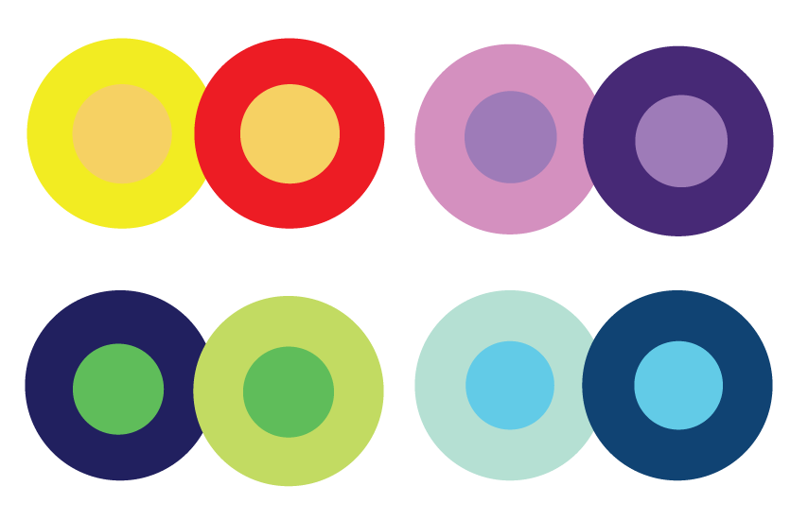

Figure 18

This is because the way in which we use two colors together changes how we perceive it. So, when you're choosing colors for your graphic designs, think about how much contrast you want throughout the design.

For instance, if you were creating a simple bar chart, would you want a dark background with dark bars? Probably not. You'd most likely want to create a contrast between your bars and the background itself since you want your viewers to focus on the bars, not the background.

### **Refer to a color wheel to identify analogous colors.**

Analogous color schemes are formed by pairing one main color with the two colors directly next to it on the color wheel. You can also add two additional colors (which are found next to the two outside colors) if you want to use a five-color scheme instead of just three colors.

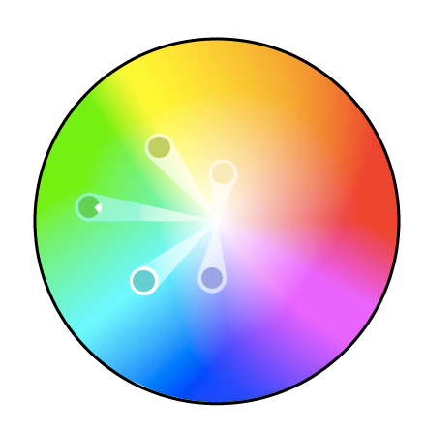

Figure 19: Color wheel and analogous colors

Analogous structures do not create themes with high contrasting colors, so they're typically used to create a softer, less contrasting design. For example, you could use an analogous structure to create a color scheme with autumn or spring colors.

# Color Tools[8]

There's been a lot of theory and practical information for actually understanding which colors go best together and why. But when it comes down to the actual task of choosing colors while you're designing, it's always a great idea to have tools to help you actually do the work quickly and easily.

Luckily, there are a number of tools to help you find and choose colors for your designs.

### **Adobe Color**

One of my favorite color tools to use while I'm designing anything -- whether it's an infographic or just a pie chart -- is Adobe Color (previously Adobe Kuler). (<https://color.adobe.com/create>)

This free online tool allows you to quickly build color schemes based on the color structures that were explained earlier in this post. Once you've chosen the colors in the scheme you'd like, you can copy and paste the HEX or RGB codes into whatever program you're using.

It also features hundreds of premade color schemes for you to explore and use in your own designs. If you're an Adobe user, you can easily save your themes to your account.

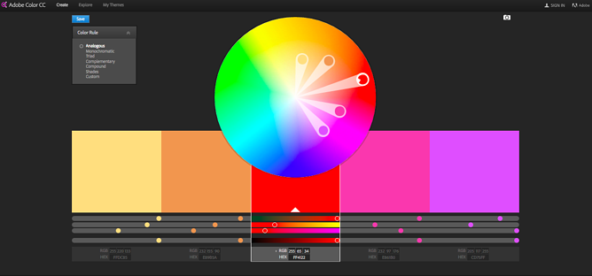

Figure 20: Adobe colors

### **Illustrator Color Guide**

I spend a lot of time in Adobe Illustrator, and one of my most-used features is the color guide. The color guide allows you to choose one color, and it will automatically generate a five-color scheme for you. It will also give you a range of tints and shades for each color in the scheme.

If you switch your main color, the color guide will switch the corresponding colors in that scheme. So if you've chosen a complementary color scheme with the main color of blue, once you switch your main color to red, the complementary color will also switch from orange to green.

Like Adobe Color, the color guide has a number of preset modes to choose the kind of color scheme you want. This helps you pick the right color scheme style within the program you're already using.

After you've created the color scheme that you want, you can save that scheme in the "Color Themes" module for you to use throughout your project or in the future.

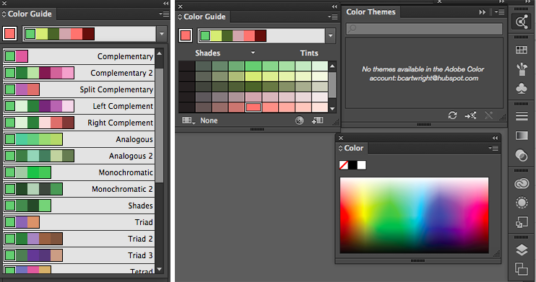

Figure 21: Illustrator colors

### **Preset Color Guides (Microsoft)**

If you're not an Adobe user, you've probably used Microsoft Office products at least once. All of the Office products have preset colors that you can use and play around with to create color schemes. PowerPoint also has a number of color scheme presets that you can use to draw inspiration for your designs.

Where the color schemes are located in PowerPoint will depend on which version you use, but once you find the color "themes" of your document, you can open up the preferences and locate the RGB and HEX codes for the colors used.

You can then copy and paste those codes to be used in whatever program you're using to do your design work.

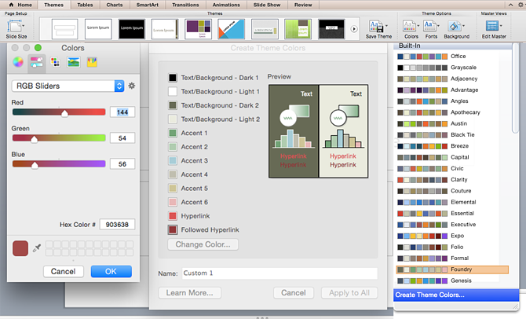

Figure 22:Microsoft colors

There's a lot of theory in this post, I know. But when it comes to choosing colors, understanding the theory behind color can do wonders for how you actually use color. This can make creating branded visuals easy, especially when using design templates where you can customize colors.

### **Coolors :**

Coolors (<https://coolors.co/>) is a useful and beginner-friendly color palette generator, perfect for getting to grips with HEX codes. You can click through random premade color palettes, play around with shades and hues, and save your favorite colors to build your own custom palette. But it’s even more fun to play around with their generator. Once you find a color you love, simply copy-paste it into any external application and start designing!

1. <https://careerfoundry.com/en/blog/ui-design/introduction-to-color-theory-and-color-palettes/>
2. <https://blog.hubspot.com/marketing/color-theory-design>
3. <https://www.tigercolor.com/color-lab/color-theory/color-harmonies.htm>
4. <https://www.tigercolor.com/color-lab/color-theory/color-harmonies.htm>
5. <https://www.tigercolor.com/color-lab/color-theory/color-harmonies.htm>
6. <https://www.interaction-design.org/literature/topics/color-theory>
7. <https://blog.hubspot.com/marketing/color-theory-design>
8. <https://blog.hubspot.com/marketing/color-theory-design>